Azure DevOps

What is Azure DevOps?
Azure DevOps is a Microsoft platform that helps software teams manage the complete software development lifecycle, from writing code to releasing an application.
Imagine you are working on an enterprise React application with five frontend developers, two backend developers, and a QA team. Azure DevOps helps everyone coordinate their work and deliver changes safely.

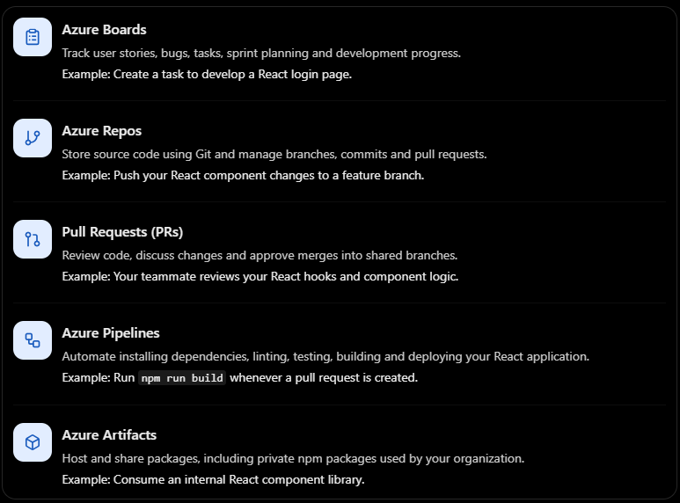

These are the five core Azure DevOps services you should recognize. For a frontend role, prioritize Azure Repos, Pull Requests, and Azure Pipelines.

2. How Azure DevOps fits into your React project
Let's say you are developing an e-commerce application using React.

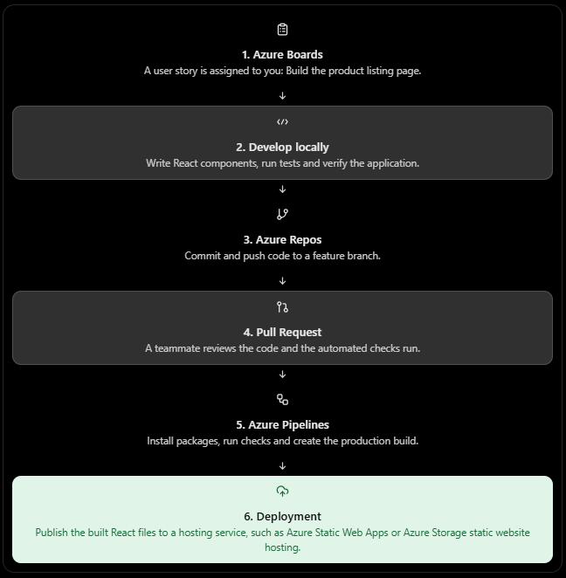

This is a typical workflow. The exact steps depend on how your organization configures its repositories, pipelines, approvals and hosting infrastructure.

What is CI/CD, and why should a React developer learn it?
This is the most important part for your frontend career.
- CI — Continuous Integration: Automatically validate code whenever developers push changes or create pull requests.
- CD — Continuous Delivery/Deployment: Prepare code for release or automatically deploy it to an environment.

For React, a CI pipeline commonly runs these commands:
npm ci
npm run lint
npm test -- --run
npm run build

These are examples, not universal commands. Your project's package.json determines which scripts are available. For example, -- --run is useful for Vitest projects, while Jest projects may use a different test command.
Step | What happens?
npm ci | Installs dependencies consistently from the lockfile.
Lint | Detects code-quality issues.
Tests | Runs automated component or unit tests.
Build | Generates optimized production files.
Deploy | Publishes the build to the target hosting environment.

If a test fails, the pipeline can fail and block the pull request from being merged, provided the repository's policies are configured accordingly.

Common Azure DevOps interview questions

